Locate files of harry user
locate the files of owner "harry" and copy to the location /root/found directory.
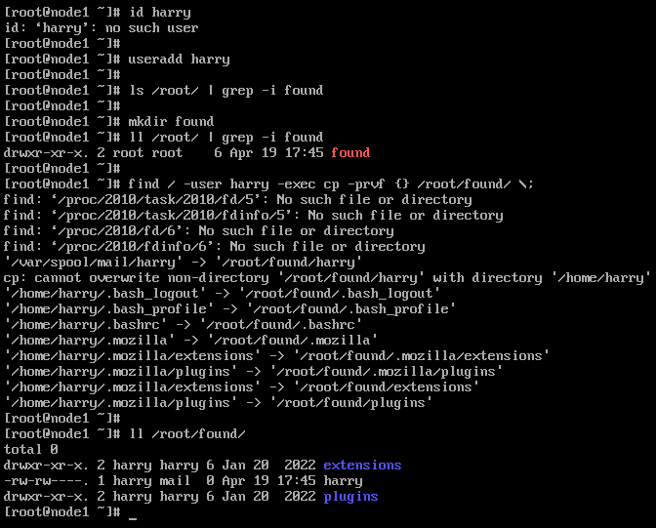

Find a string
Find the string "surd" from "/usr/share/dict/words" file and copy those lines in /root/lines.txt file.
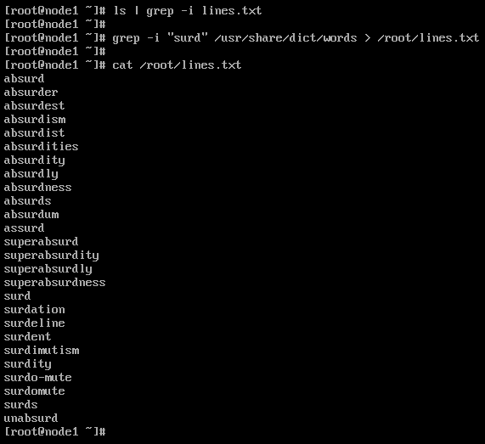

Archive and Compression
Archive & compress for /etc directory under /var/tmp/archive.tar.bz2 format
